Chapter One: Introduction To Linux
Ridwo Dahir Maxamed
ID C6240097
Assignment
Whoami: Display The Current Username
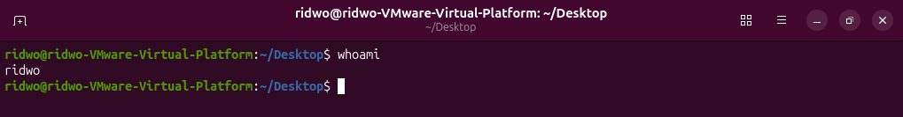
PWD:Display the current working directory.
Uname-r: Display The linux kernal version.
Cat /etc/os-release: Displays Linux distribution information
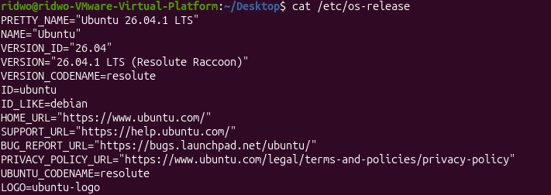
Ls: Lists files and directories

Chapter Two Linux

Cd :change current directory

cd .. Moves one directory up.
cd . :Refers to the current directory.
cd - Returns to the previous directory.
ls / Lists the contents of the root directory.
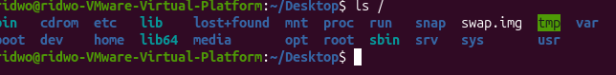
ls /home Lists the contents of the home directory.
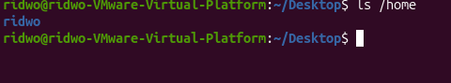
ls -a Shows all files, including hidden files. 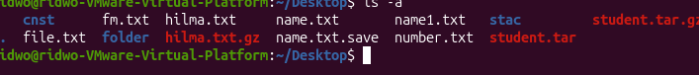
ls -l Displays files in long format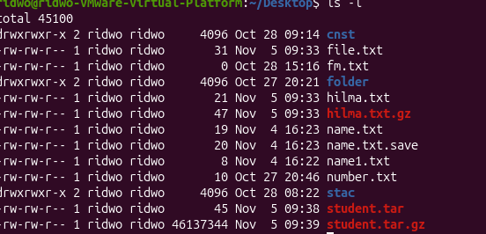g format.
ls -h Displays file sizes in human-readable format.
ls -lh Shows detailed information with readable file sizes.
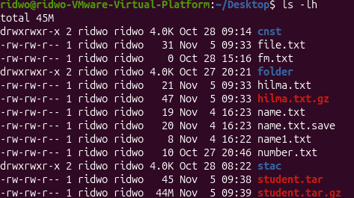

ls -lah Shows all files in detailed, readable form
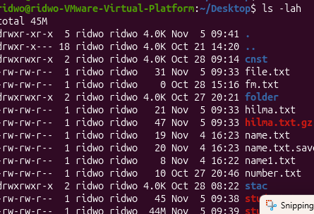
Terminal and Bash commands
echo $SHELL Displays the current shell.
history Displays previously executed commands.
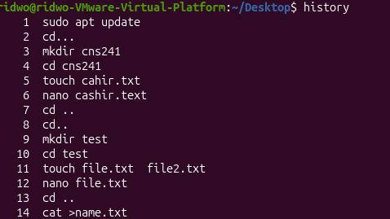

2 Getting Help
Man ls: Opens the manual page for ls.
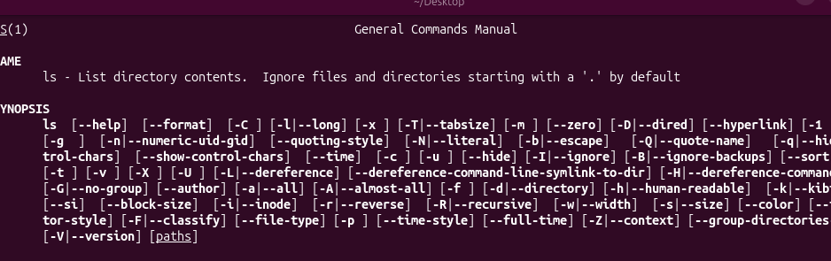
help cd Displays help for the Bash cd command.
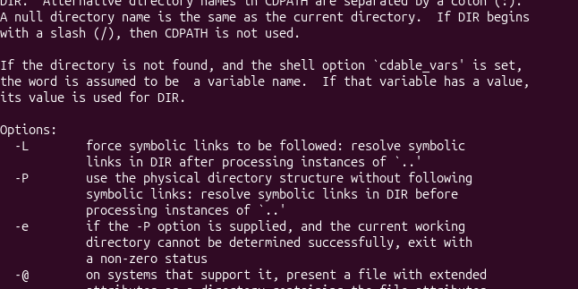
mkdir --help Displays help for mkdir.
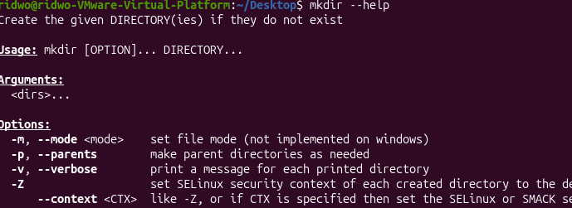
info command :Opens the information manual.
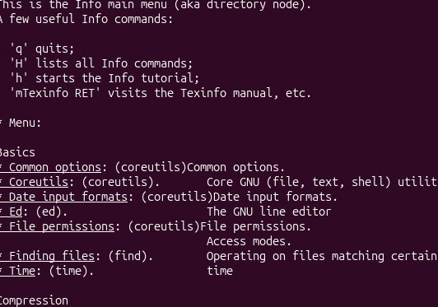
3 Creating Files & Directories
touch name .txt Creates an empty file.
touch file2.txt.txt test.txt Creates two empty files.
mkdir week3 Creates a directory named week3.
mkdir -p projects/linux Creates nested directories.
mkdir -p ~/ch2lab/notes Creates the notes directory and its parent directories. mkdir ~/ch2lab/backup Creates a backup directory. 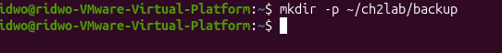
rm name.txt Removes a file.

rm -i :test.txt Asks for confirmation before removing a file.
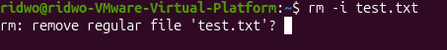
rmdir DIR :Removes an empty directory.

Cp: file1.txt file2.txt Copies a file.
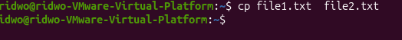
mv file2.txt old.txt Renames a ridwo.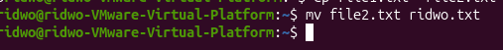
mv file1.txt ridwo.txt Changes the filename
.mv ridwo.txt ~/Documents/ Moves a file to Documents.
: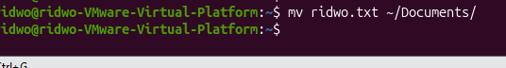

echo $HOME: Displays the home directory path.
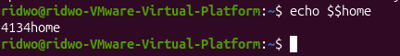
echo $USER :Displays the current username.

echo $PATH :Displays the PATH environment variable.
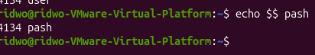
echo $COURSE Displays the COURSE variable's value.
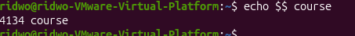
COURSE=linux Creates a variable named COURSE.

ls /usr/bin/ls :Checks the location of the ls command.
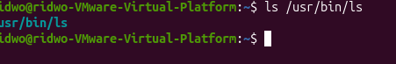
ls /usr/bin/mkdir Checks the location of the mkdir command.
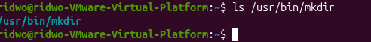
ls -a ~ : Lists all files in the home directory.
echo “Hello $ USER” : double quotes
echo ‘Hello $USER’ : single quote
echo Hello $USER : Display hello and the username

CHAPTER THREE
cat Display file contents
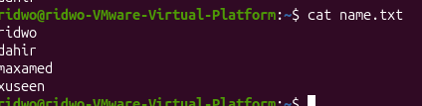
cat -n Display contents with line numbers
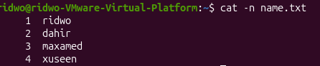
less Read long files page by page
more Display file page by page
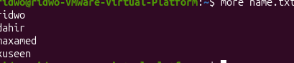
head Show first 10 lines
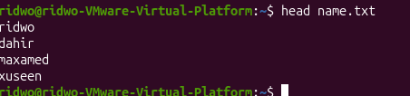
head -n 2 Show first 2 lines
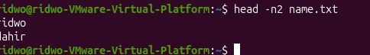
tail Show last 10 lines
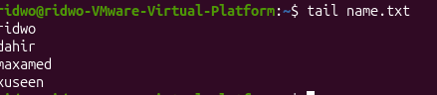
tail -n 2 Show last 2 lines
tail -f Monitor file in real time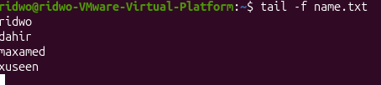
file Identify file type
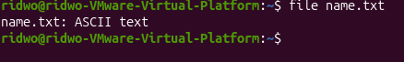
stat Display file metadata
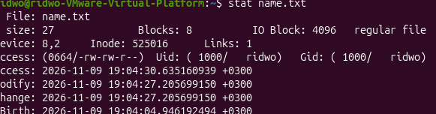
ls -l Display detailed file information
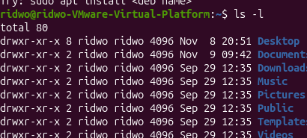
which Find executable location
type Identify command type
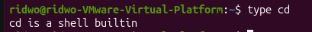
command -v Find how command is resolved
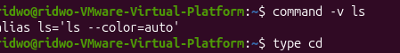
whereis Locate binary and manual pages
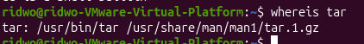
find Search files and directories
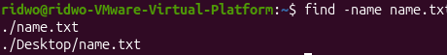
locate Search files using database
grep Search text inside files
grep -n Show matching line numbers
grep -i Ignore uppercase/lowercase
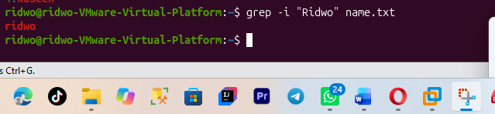
grep -v Exclude matching lines
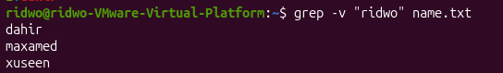
grep -r Search recursively
grep -rn Recursive search with line numbers
| > | Create or overwrite file
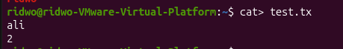
| >> | Append text to file
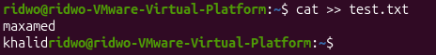
| 2> | Redirect error messages
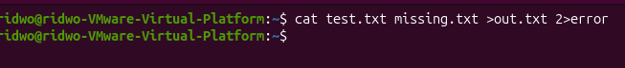
| < | Read input from file
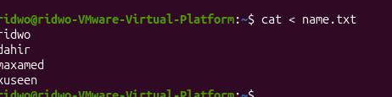
| ; | Run commands sequentially
| && | Run next command if first succeeds
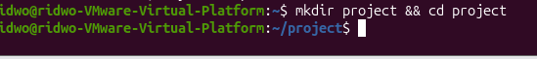
| || |: Run next command if first fails

sort 10.sort
Function: Arranges lines of text in sorted order.
Explanation: The sort command organizes lines in a file. By default, it sorts lines alphabetically according to their characters. It is useful when arranging names, words or other text information.
Example:
sort him.txt
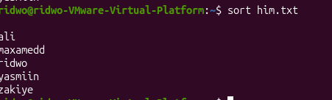
| sort -n | Sort numerically
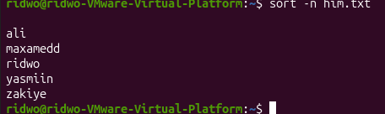
| sort -r | Reverse sorting
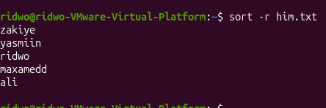

| sort -rn | Reverse numeric sorting |
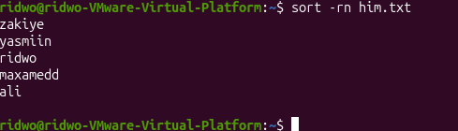
| uniq | Remove adjacent duplicates 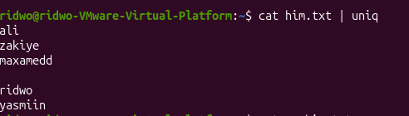
| uniq -c | Count repeated lines |
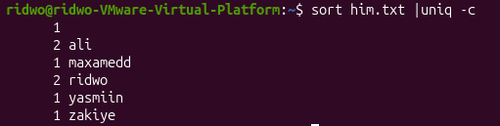
| uniq -d | Display duplicate lines |
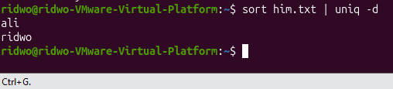
| cut | Extract characters or fie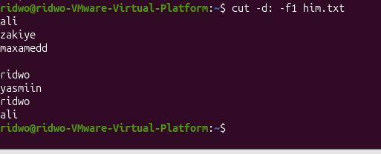lds |
| paste | Combine corresponding lines
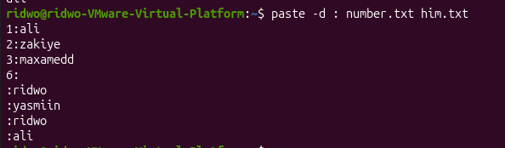
| wc | Count lines, words and bytes |
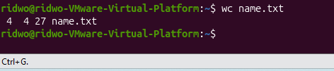
| wc -l | Count lines
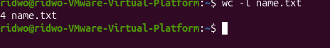
| wc -w | Count words
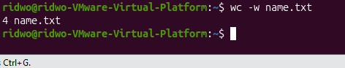
| wc -c | Count bytes
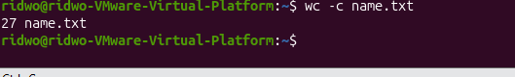
| wc -m | Count characters
| tr | Translate characters
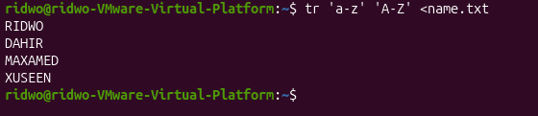
| tr -d | Delete characters
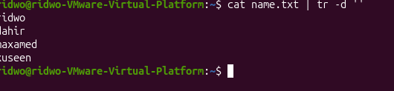
| tr -s | Squeeze repeated characters
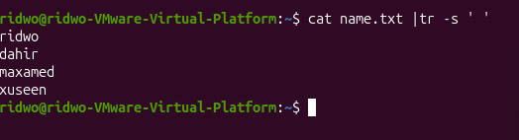
tar Create and manage archives
tar -cf Create tar archive 
tar -cvf Create archive and display filenames
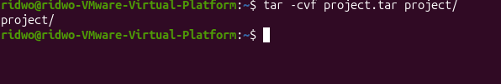
tar -tf List archive contents
tar -xf Extract archive

tar -czf Create gzip compressed archive
gzip Compress file
gzip -k Compress and keep original
gzip -9 Best compression level
gunzip Decompress gzip file
gunzip -c Display decompressed contents
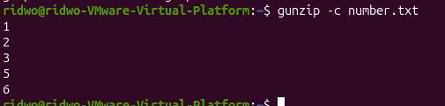
3.5 Hard Links and Symbolic Links
This section explains how Linux creates links between files. Links allow users to access files through different names or paths.
1. ln
Function: Creates a hard link.
Explanation: The ln command creates another directory entry that refers to the same file data as the original file. A hard link and the original file share the same inode number. This means both names refer to the same underlying file contents.
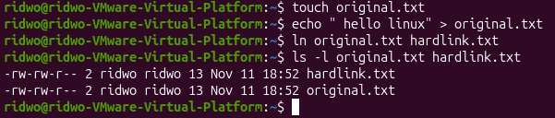

2. ln -s
Function: Creates a symbolic or soft link.
Explanation: The -s option creates a symbolic link. A symbolic link is a special file that stores the path to another file or directory. It works like a shortcut. Unlike a hard link, it has its own inode number and points to the target path.
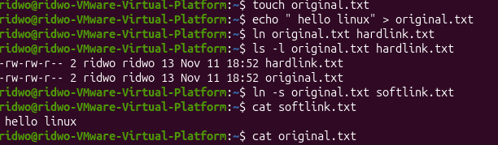

CHAPTER FOUR LINUX
1. echo $$
Explanation:
The echo command displays text or variable values in the terminal. The special variable $$ represents the Process ID (PID) of the current shell.
It helps you identify the PID of the terminal shell you are currently using.
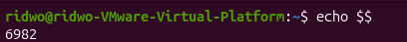
2. ps
Explanation:
The ps command stands for Process Status. It displays information about processes currently running on the system.
It provides a snapshot of processes at the moment you execute the command. Unlike top, it does not continuously refresh.
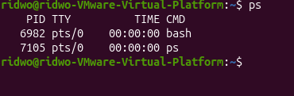
3. ps -f
Explanation:
The -f option means Full Format. It displays more detailed information about running processes, including the process owner, PID, PPID and starting time.
PPID means Parent Process ID. It identifies the process that started another process.
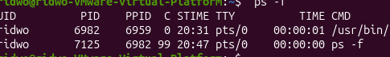
4. ps -p PID
Explanation:
The -p option allows you to display information about one specific process using its PID.
Instead of displaying multiple processes, it focuses on the process number you provide.
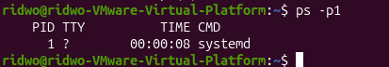
5. ps -o
Explanation:
The -o option allows you to select which columns you want to display.
This is useful when you need specific information instead of a complete process listing.
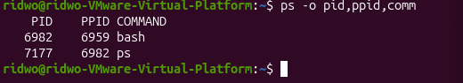
6. ps aux
Explanation:
The ps aux command displays all running processes on the entire system, including processes belonging to other users.
It also displays CPU usage, memory usage, process status and other details.
It is useful when you want to monitor all processes running on Ubuntu.
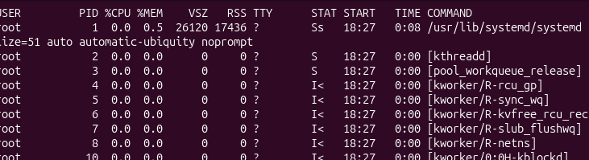
8. ps -ef
Explanation:
The ps -ef command displays every process running on the system using full-format information.
It includes PID, PPID, user, starting time and command.
It is similar to ps aux, but uses a different output format.
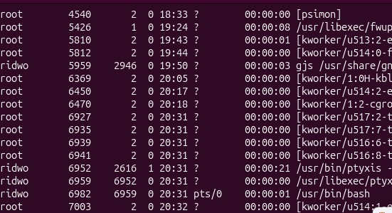
10. ps -ef | head -n 4
Explanation:
This command displays only the first four lines of the complete process list.It is useful when you want to inspect a small part of the process list without displaying everything.
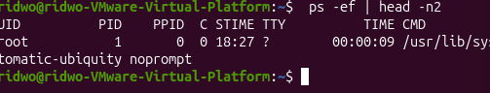
11. pstree -p
Explanation:
The pstree command displays running processes in a tree structure.
It shows the relationship between parent and child processes.
The -p option displays the PID numbers next to process names.
Example:
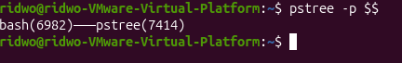
12. top
Explanation:
The top command provides a live view of running processes. It continuously updates the information every few seconds.
It helps administrators monitor CPU usage, RAM usage, running processes and system performance.
Example:
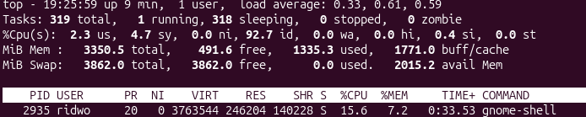

14. command -v htop
Explanation:
The command -v command checks whether a command or program is available in the system and displays its location.
It is useful for checking whether htop is installed before trying to run it.
Example:
15. htop
Explanation:
The htop command is an interactive process-monitoring tool similar to top.
It displays running processes using colours, provides mouse support and allows users to manage processes interactively.
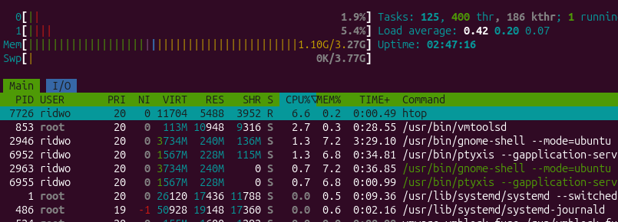
16. htop -u student
Explanation:
This command opens htop and displays only the processes belonging to the specified user.
Example:
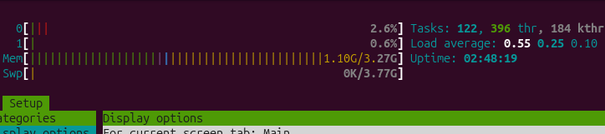
17 htop -t
Explanation:
The -t option displays processes in a tree structure.
Child processes appear underneath their parent processes.
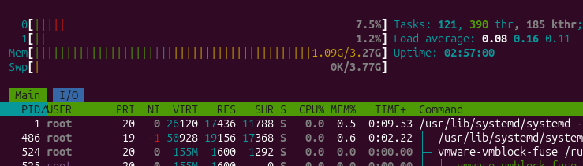
18. sleep
Explanation:
The sleep command pauses execution for a specified amount of time.
It is commonly used for testing foreground and background processes.
19. sleep 30 &
Explanation:
The & symbol runs a command in the background.
Instead of making the terminal wait until the process finishes, Linux returns the prompt immediately.
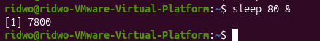
20. gnome-calculator &
Explanation:
This command opens the GNOME Calculator application in the background.
The & symbol allows the terminal to remain available while the calculator is running.
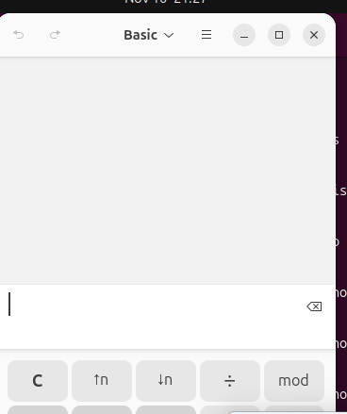
22. Ctrl + Z
Explanation:
Ctrl+Z sends the SIGTSTP signal to the foreground process.
Unlike Ctrl+C, it does not terminate the process. It pauses the process and returns control to the terminal.
23. jobs
Explanation:
The jobs command displays background and stopped jobs associated with the current shell.
It helps you identify which jobs are running, stopped or waiting.
24. jobs -l
Explanation:
The -l option displays the job list together with the PID of each job.
It provides more information than the normal jobs command.
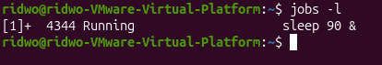
25. bg %N
Explanation:
The bg command resumes a stopped job and allows it to continue running in the background.
%N represents the job number.

26. fg %N
Explanation:
The fg command brings a background or stopped job into the foreground.
The terminal becomes occupied by that job until it finishes or is stopped.
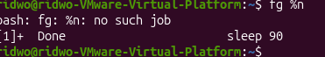
28. kill -l
Explanation:
The kill -l command displays the available signal names and their corresponding numbers.
Signals are messages sent to processes to request actions such as stopping or reloading.
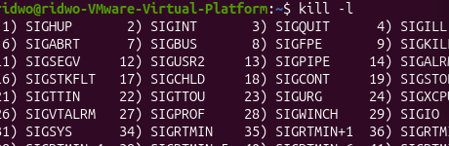
29. kill -l 15
Explanation:
This command displays the name of the signal associated with number 15.
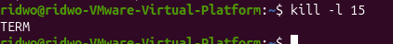
34. ps -p PID
Explanation:
This command checks whether a process with a specific PID is still running.
It is useful after sending a termination signal to confirm whether the process has stopped.
35. kill -9
Explanation:
This command sends SIGKILL (signal 9) to a process.
It forcefully terminates the process immediately without allowing it to save data or perform normal cleanup.
It should only be used as a last resort when normal termination does not work.
37. pkill -u USER NAME
Explanation:
The pkill command sends a signal to processes matching a specified name or pattern.
The -u option limits the action to processes owned by a particular user.
By default, it sends SIGTERM.
39. nice
Explanation:
The nice command starts a new process with a specified CPU scheduling priority, called niceness.
Niceness values range from -20 to 19.
-20: Highest scheduling priority.
0: Default priority.
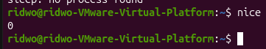
40. nice -n N command
Explanation:
The -n option specifies the niceness value when starting a new process.
It is useful when you want a new process to have lower scheduling priority so that other processes can receive more CPU time.
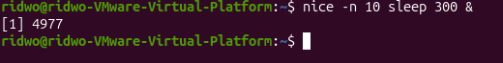
41. ps -o pid,ni,comm -p PID
Explanation:
This command displays the PID, niceness value and command name of a specific process.
It helps you check the priority assigned to a process.
42. renice -n N -p PID
Explanation:
The renice command changes the niceness value of a process that is already running.
Unlike nice, which sets priority when starting a new process, renice modifies the priority of an existing process.
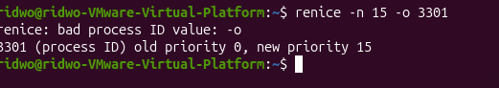
43. sudo renice
Explanation:
The sudo command allows an authorized user to execute a command with administrator privileges.When used with renice, it allows the administrator to make the process's niceness lower and give it higher scheduling priority.
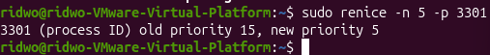
44. top -p PID
Explanation:
This command opens the top monitoring tool and displays information about one specific process.
It is useful when you want to monitor one process instead of viewing every running process.
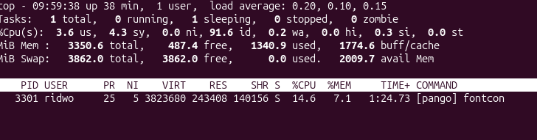45. uname
Explanation:
The uname command displays information about the currently running Linux kernel and the machine's hardware architecture.It helps administrators identify the kernel and system information.
46. uname -r
Explanation:
The -r option displays the kernel release version currently running on the system.
It is useful when checking kernel versions or reporting system problems.
Example:
47. uname -m
Explanation:
The -m option displays the machine's hardware architecture.
It helps identify whether the system uses an architecture such as x86_64 or aarch64.
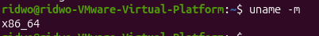
48. uname -n
Explanation:
The -n option displays the network hostname of the computer.
The hostname is the name used to identify the machine on a network.
49. uname -a
Explanation:
The -a option displays all available system information in one line.
release and hardware architecture
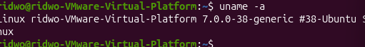 .
50. hostnamectl
Explanation:
The hostnamectl command displays information about the computer's hostname, operating system, kernel and virtualization environment.
It helps identify whether the system is running on physical hardware or inside a virtual machine.
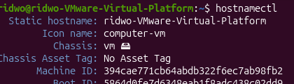
51. hostnamectl hostname
Explanation:
This command displays only the hostname of the computer.
It is useful when you need the system name without displaying the full system information.
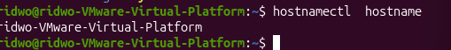
52. uptime
Explanation:
The uptime command displays how long the computer has been running since its last boot.
It also shows the current time, number of logged-in users and system load averages.
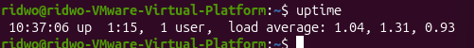
53. uptime -p
Explanation:
The -p option displays the system's running time in a human-readable format.
Instead of displaying technical time information, it uses words such as hours and minutes.
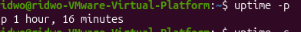
54. uptime -s
Explanation:
The -s option displays the exact date and time when the computer was last started.It is useful when investigating unexpected restarts or checking the last boot time.
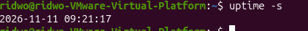
55. nproc
Explanation:
The nproc command displays the number of processing units available to the current process.
It helps determine how many CPUs are available for running programs.
Example:
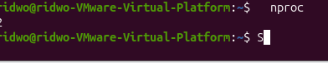

56. free
Explanation:
The free command displays information about RAM and swap memory.
It shows the total memory, used memory, free memory, shared memory and available memory.
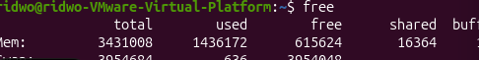
57. free -h
Explanation:
The -h option means human-readable format.
It displays memory sizes using understandable units such as MiB and GiB instead of large numbers of kilobytes.
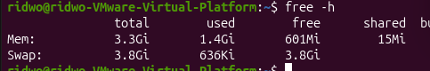
58. free -m
Explanation:
The -m option displays memory information in mebibytes (MiB).
It is useful when you want to read memory usage in a smaller unit.
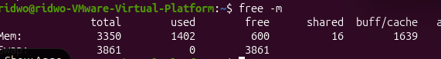

59. free -h -s 2
Explanation:
This command displays memory information in human-readable format and refreshes the results every two seconds.
It helps monitor memory usage continuously while opening or running applications.
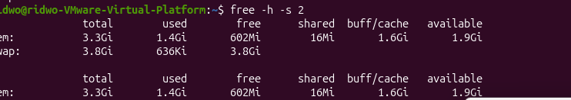
60. lscpu
Explanation:
The lscpu command displays detailed information about the CPU architecture and processor.
It provides information such as CPU count, processor model, architecture and virtualization details.
Example:
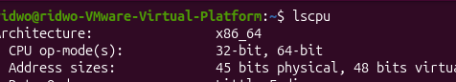
61. lscpu | less
Explanation:
This command displays CPU information page by page using less.
It is useful when the CPU information is too long to fit on one screen.
Example:
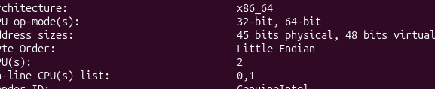
62. lsblk
Explanation:
The lsblk command lists block devices detected by the Linux kernel.
Block devices include hard disks, SSDs, partitions and CD-ROM devices.
It helps you understand which storage devices are connected to the computer.
Example:
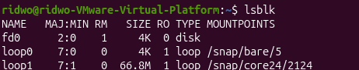
63. lsblk -e 7
Explanation:
The -e 7 option excludes devices with major device number 7, which are loop devices.
Loop devices are commonly associated with Snap packages.
Example:
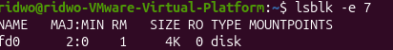
This gives a cleaner list of actual storage devices.
64. lsblk -e 7 -d -o NAME,SIZE,MODEL
Explanation:
This command displays only whole storage devices and excludes loop devices.
- -e 7: Excludes loop devices.
- -d: Displays whole disks only.
- -o: Selects the columns to display.
65. ls /proc
Explanation:
The ls command lists files and directories.
When used with /proc, it displays information provided by the Linux kernel about running processes and system information.
/proc is a virtual filesystem generated by the kernel, not a normal folder stored on the disk.
Example:
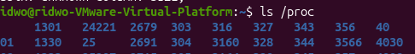
66. ls -l /proc/meminfo
Explanation:
This command displays detailed file information about /proc/meminfo.
The -l option provides a long listing, showing permissions, owner, size and modification information.
67. cat /proc/uptime
Explanation:
The cat command displays the contents of a file.
When used with /proc/uptime, it displays how many seconds the system has been running since boot and the accumulated idle time.
68. cat /proc/loadavg
Explanation:
This command displays the system load averages directly from the /proc filesystem.It shows the average number of processes running or waiting over 1, 5 and 15 minutes.
Example:
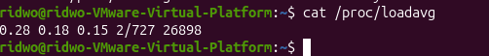
69. ls /proc/$$
Explanation:
This command lists the files and directories associated with the current shell process.
The $$ variable automatically represents the PID of the current shell.
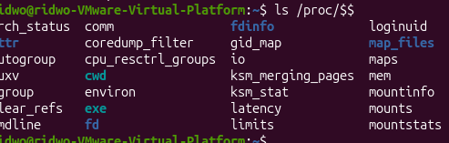
70. head -n 7 /proc/$$/status
Explanation:
The head command displays the beginning of a file.
The -n 7 option displays the first seven lines.
Here it displays information about the current shell process, including its name, state, PID and PPID.
71. cat /proc/1/comm
Explanation:
This command displays the short name of process number 1.
On Ubuntu systems using systemd, PID 1 is normally the systemd process.
72. grep -m 1 "model name" /proc/cpuinfo
Explanation:
The grep command searches for specific text inside a file.
The -m 1 option stops after finding the first matching line.
This example searches for the CPU model name inside /proc/cpuinfo.
73. grep -c ^processor /proc/cpuinfo
Explanation:
The -c option counts the number of matching lines.
The ^processor pattern searches for lines beginning with the word processor.
This command helps identify the number of processor entries in /proc/cpuinfo.

74. head -n 3 /proc/meminfo
Explanation:
This command displays the first three lines of /proc/meminfo.
The file contains detailed information about the system's memory usage.
Example:
It displays:
MemTotal.
MemFree.
75. ls /sys
Explanation:
The ls command lists the main categories inside /sys.
The /sys filesystem provides information about hardware devices, drivers and kernel objects.
Example:
76. ls /sys/block
Explanation:
This command displays block devices detected by the Linux kernel.
It helps identify disks and other block storage devices.

77. ls /sys/class/net
Explanation:
This command lists the network interfaces available on the computer.
A network interface is a device or virtual interface used for network communication.
Example:
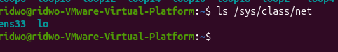
78. cat /sys/class/net/enp0s3/address
Explanation:
This command displays the hardware address (MAC address) of the specified network interface.It is useful when identifying a network card.
79. ps -p 1 -o pid,comm
Explanation:
This command displays the PID and command name of process number 1.
It helps confirm that systemd is the first process running on an Ubuntu system.
80. systemctl cat cron
Explanation:
The systemctl cat command displays the unit file associated with a service.
A unit file describes how systemd manages and starts a service.
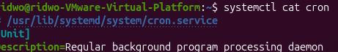
81. systemctl status cron
Explanation:
The systemctl status command displays the current status and information about a service.
It tells you whether the service is running, stopped or failed, and whether it is enabled at boot.

82. systemctl is-active cron
Explanation:
This command checks whether a particular service is currently active.
It provides a simple answer without displaying the full status report.
Example:
83. systemctl is-enabled cron
Explanation:
This command checks whether a service is configured to start automatically when the computer boots.It is important to understand that enabled and active are different.

84. sudo systemctl stop cron
Explanation:
The stop action stops a currently running service.
The sudo command is used because stopping system services requires administrator privileges.
85. sudo systemctl start cron
Explanation:
The start action starts a service that is currently stopped.
It is useful when a service is inactive and you want to run it again.
86. sudo systemctl restart cron
Explanation:
The restart action stops the service and starts it again.
It is useful when you want to restart a service or apply changes that require restarting.
87. systemctl show -p MainPID cron
Explanation:
The systemctl show command displays selected properties of a systemd service.
The -p MainPID option requests only the main process ID.

88. sudo systemctl reload ssh
Explanation:
The reload action asks a running service to read its configuration files again without completely stopping the service.
It is useful when a service supports configuration reloading and you want to avoid interrupting existing connections.
89. sudo systemctl reload cron
Explanation:
This command attempts to reload the cron service configuration without stopping it.However, the slide explains that cron does not support the reload action
90. sudo systemctl reload-or-restart cron
Explanation:
This command first attempts to reload the service.
If the service does not support reload, systemd restarts it instead..
91. sudo systemctl enable cron
Explanation:
The enable action configures a service to start automatically when the system boots.
It does not necessarily start the service immediately.
Example:

92. sudo systemctl disable cron
Explanation:
The disable action prevents a service from starting automatically during future system boots.It does not automatically stop a service that is already running.
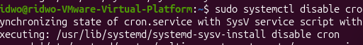
93. sudo systemctl enable --now cron
Explanation:
This command enables the service for automatic startup and starts it immediately.
The --now option combines the boot setting with an immediate action.
Example:
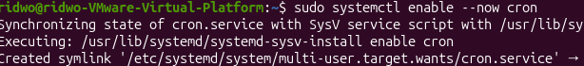
94. systemctl list-units --type=service --state=running
Explanation:
This command lists services currently running under systemd.
The options filter the results so that only running services are displayed.
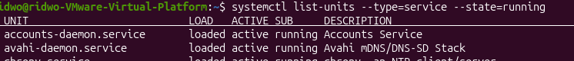

95. systemctl list-units --type=service --state=failed
Explanation:
This command displays service units that have failed.It is useful when troubleshooting system problems because it helps identify services that did not start or operate correctly.
96. journalctl
Explanation:
The journalctl command is used to read system logs collected by systemd.
System logs contain information about system activities, services, errors and events.It is useful when troubleshooting problems because it helps identify what happened before a failure.
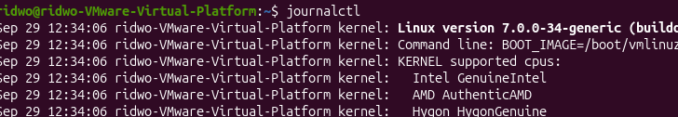
97. journalctl -n 3
Explanation:
The -n option displays a specified number of the most recent journal entries.
It is useful when you only want to see the latest system messages.
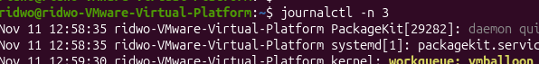

98. journalctl -b
Explanation:
The -b option displays journal messages from the current boot session.
It helps administrators investigate problems that happened after the computer was last started.
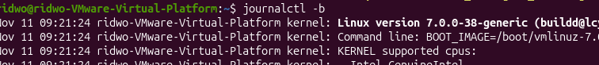
99. journalctl -b -p err
Explanation:
This command displays error-level messages and more serious messages from the current boot session.
It helps you focus on problems instead of reading every normal system message
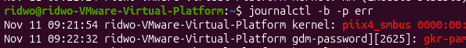
100. journalctl -xe
Explanation:
This command displays recent journal messages and adds explanatory information where available.
-x: Adds explanatory text.
-e: Jumps to the end of the jou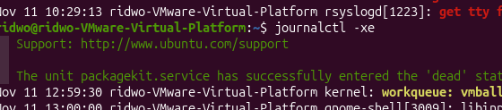
101. journalctl -f
Explanation:
The -f option follows the journal and displays new log entries as they are created.
It works similarly to watching a live stream of system events.
102. logger "week 8 test from student"
Explanation:
The logger command writes a test message into the system logging system.
It is useful for testing whether new messages appear in the journal.
Example:
103. journalctl -u cron -f
Explanation:
This command follows new log messages generated by one specific service.
-u cron: Selects the cron service.
-f: Displays new messages continuously
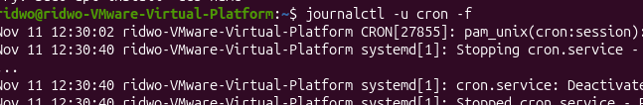
104. ls /var/log
Explanation:
The /var/log directory stores traditional Linux system log files.The ls command lists the log files and directories available in that location.
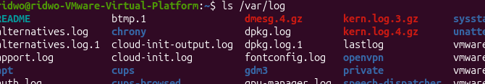
105. less /var/log/syslog
Explanation:
This command opens the system log file using the less pager.
It allows you to read the log page by page without modifying the file.
106. tail -n 3 /var/log/kern.log
Explanation:
The tail command displays the end of a file.
The -n 3 option displays only the last three lines.
This is useful when checking the most recent kernel messages.
107. tail -f /var/log/syslog
Explanation:
The -f option follows a log file and continuously displays new lines as they are added.
It is useful for monitoring system activity in real time.
Example:
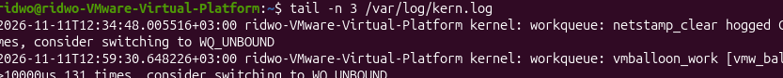
108. grep sudo /var/log/auth.log
Explanation:
The grep command searches for lines containing the word sudo in the authentication log.
It is useful when checking administrative activities and commands executed using sudo.
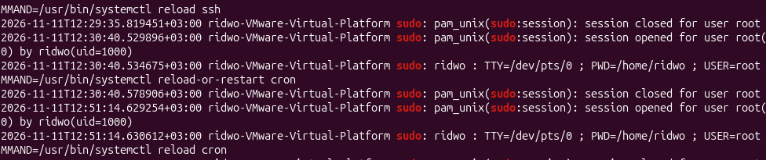
109. grep sudo /var/log/auth.log | tail -n 1
Explanation:
This command searches the authentication log for sudo-related entries and displays only the latest matching line.
grep sudo: Finds lines containing sudo.
tail -n 1: Displays the last matching line.
109. grep sudo /var/log/auth.log | tail -n 1
Explanation:
This command searches the authentication log for sudo-related entries and displays only the latest matching line.
grep sudo: Finds lines containing sudo.
tail -n 1: Displays the last matching line.
110. journalctl _COMM=sudo -n 1
Explanation:
This command displays
the most recent journal entry generated by a process whose command name is sudo.
_COMM=sudo: Filters messages associated with the sudo command.
-n 1: Displays one recent entry.
111. last -n 2
Explanation:
The last command displays information about previous user login sessions and system reboots.
The -n 2 option limits the output to the latest two records.
112. dmesg
Explanation:
The dmesg command displays messages generated by the Linux kernel.
These messages contain information about hardware detection, drivers, devices and system startup.
It is useful when troubleshooting hardware or device-related problems.
Example:

113. sudo dmesg -T | tail -n 2
Explanation:
This command displays the latest two kernel messages with readable date and time information.
sudo: Runs with administrator privileges.
dmesg: Displays kernel messages.
-T: Converts timestamps into readable clock times.
tail -n 2: Shows the final two messages.
114. sudo dmesg | less
Explanation:
This command displays kernel messages page by page.
It is useful when you want to inspect a large amount of kernel information without scrolling through everything at once.
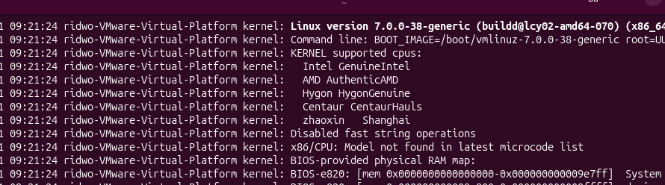

115. journalctl -k -b
Explanation:
This command displays kernel messages collected by the systemd journal during the current boot session.
-k: Displays kernel messages only.
-b: Displays messages from the current boot.
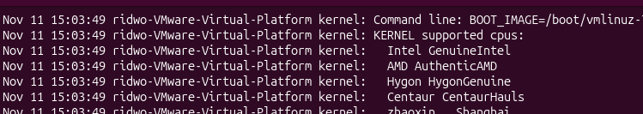
116. sudo shutdown now
Explanation:
The shutdown command safely shuts down the computer.
The now option means the shutdown should happen immediately.
Before switching off, Linux stops services in an orderly manner and performs the necessary
117. sudo shutdown -r +5 "Rebooting for the lab"
Explanation:
This command schedules the computer to restart after five minutes.
-r: Reboot instead of powering off.
+5: Wait five minutes.
The quoted text: Provides a shutdown message.

119. sudo reboot
Explanation:
The reboot command restarts the computer immediately.
It performs an orderly restart of the operating system.
120. sudo poweroff
Explanation:
The poweroff command safely shuts down the operating system and switches off the computer.
It stops running services and performs the required shutdown operations.

